Executive Summary

AP-05 Executive Summary - 91.200(c), 91.220(b)
1. Introduction

2. Summarize the objectives and outcomes identified in the Plan
This could be a restatement of items or a table listed elsewhere in the plan or a reference to another location. It may also contain any essential items from the housing and homeless needs assessment, the housing market analysis or the strategic plan.
As the City pursues these strategies and objectives over the next years, the affordability of decent rental and owned housing units for Marysville’s low- and moderate-income residents, as well as the availability and accessibility of decent housing for people who are homeless or have special needs, should increase. Continued support for public services should aide in the availability, accessibility, and sustainability of a suitable living environment for low- and moderate-income residents. Increased support for transitional housing and permanent supportive housing should increase the ability of homeless and at risk of homelessness population's transition to permanent housing. Additional public facilities improvements will add to the availability, accessibility and sustainability of a suitable living environment for low-and moderate-income residents. Additional public services should help specified populations in maintaining their residences and independence.

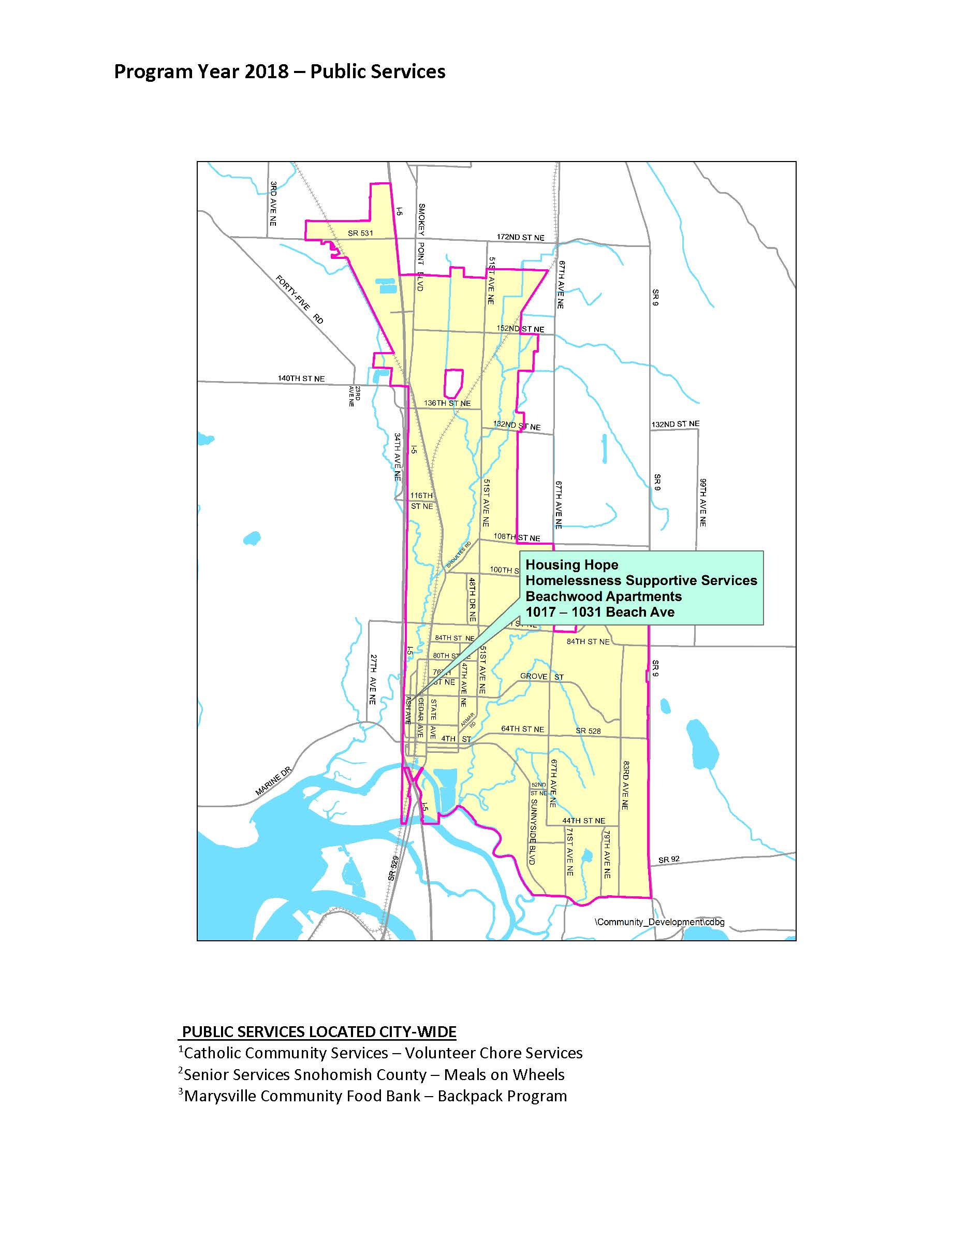
Public Services
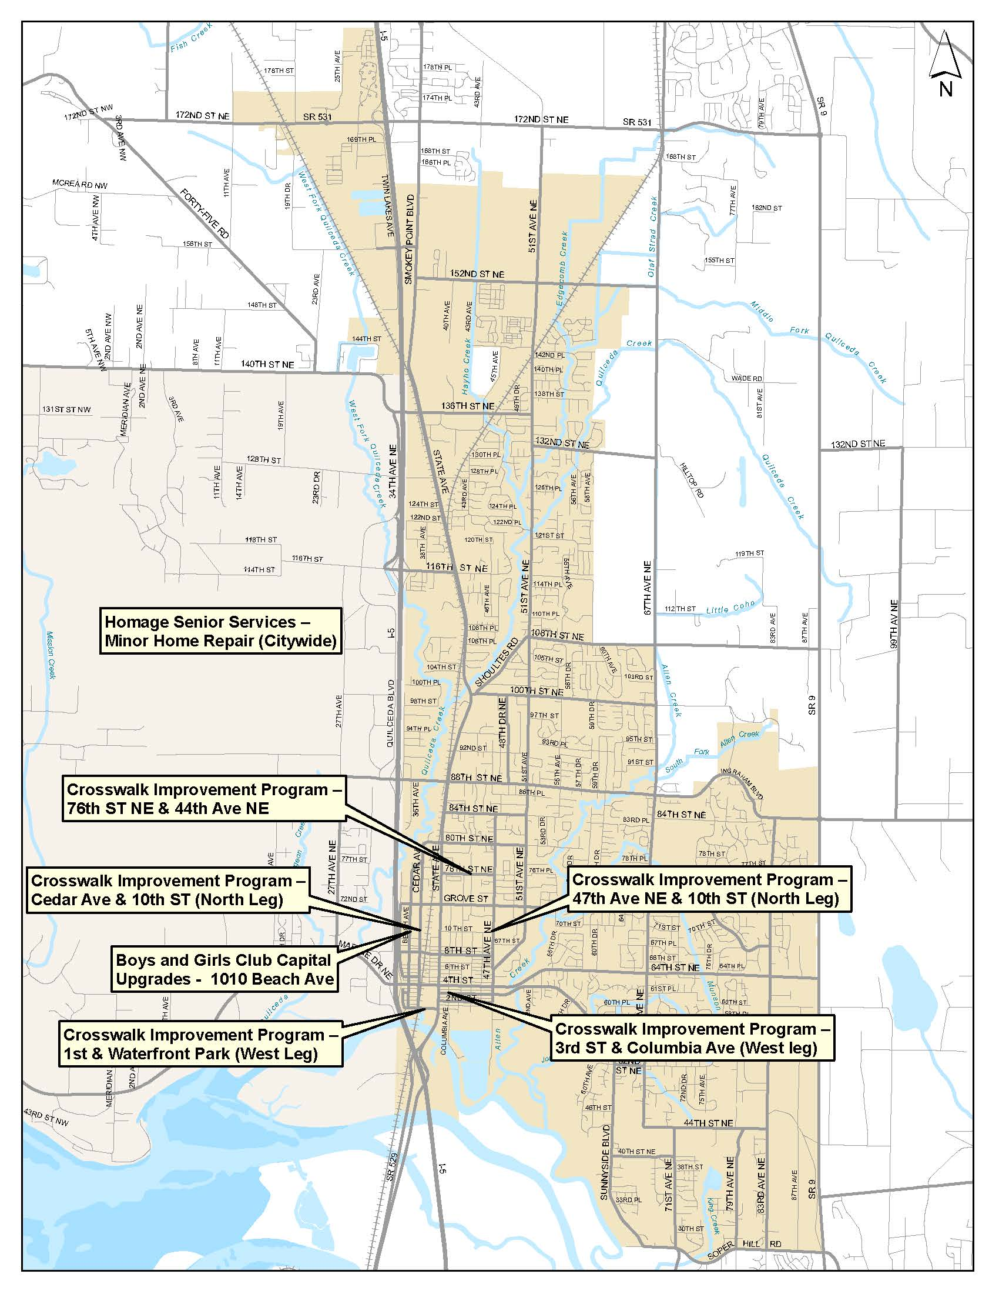
Capital Projects
3. Evaluation of past performance
This is an evaluation of past performance that helped lead the grantee to choose its goals or projects.
There has been great success in assisting underserved populations with household repairs and chores, which enables them to retain their independence and remain in their homes. Over 200 individuals benefited from the CDBG funds allocated to the agencies which provide minor home repair and chore services to low-income seniors and disabled persons each program year. The agencies are providing a much-needed service and acting in a timely manner.
Another need that has been served by the allocation of CDBG funds has been assistance to homeless and at risk of homelessness individuals and families. For each of the Program Years that have been completed, 70 individuals (20 families) had access to transitional housing as well as supportive services to aid them in moving towards securing permanent housing.
The Marysville Food Bank Backpack program was very successful in providing nutritious meals to low income children throughout the City. With CDBG funds, the program was able to expand from only Elementary schools to all of the middle and high schools within the City. The City funds a program to provide low-income senior and disabled adults with nutritious meals at their homes, and that program reached its expected goal.
A number of Capital Improvement projects were also completed which improved access to, and improved facilities, for low-moderate income individuals, including improvements to facilities that provide services to low-income children as well as a public park in a low-income neighborhood.
Due to the positive performance outcomes and, in some cases, exceedance of goals, many of the same programs were selected to receive funding for PY2018. The above mentioned past performances helped guide the City in its selection of activities for the next year.

4. Summary of Citizen Participation Process and consultation process
Summary from citizen participation section of plan.
To ensure that all interested and affected parties have an opportunity to participate in development of the 2018 Action Plan, the City solicited input from citizens and the public and nonprofit agencies that serve them, through public meetings, public hearings, a 30-day public comment period, and general communications. Public meeting and public hearing comments and written public comments were reviewed and incorporated into the Annual Action Plan as appropriate.

5. Summary of public comments
This could be a brief narrative summary or reference an attached document from the Citizen Participation section of the Con Plan.
No public comments were received.

6. Summary of comments or views not accepted and the reasons for not accepting them
N/A
7. Summary
The Annual Action Plan is made available in multiple formats and in multiple locations around the City in an effort to provide options for citizens. In addition, the plan is made available on the City's webpage and a News Bulletin is released in local circulations as well on Social Media and the City's public television channel.

PR-05 Lead & Responsible Agencies - 91.200(b)
1. Agency/entity responsible for preparing/administering the Consolidated Plan
The following are the agencies/entities responsible for preparing the Consolidated Plan and those responsible for administration of each grant program and funding source.
Agency Role | Name | Department/Agency

CDBG Administrator | MARYSVILLE | Community Development
Table 1 – Responsible Agencies

Narrative
The City of Marysville’s Community Development Department is the lead agency responsible for preparing the Consolidated Plan and for planning, developing, and implementing the CDBG Program. Several key public and nonprofit agencies, as listed in the Annual Action Plan, are expected to administer the programs covered by this plan.

Consolidated Plan Public Contact Information
City of Marysville
Community Development Department
80 Columbia Ave.
Marysville WA 98270
Amy Hess, Associate Planner
360-363-8215
ahess@marysvillewa.gov
Chris Holland, Planning Manager
360-363-8207
cholland@marysvillewa.gov

AP-10 Consultation - 91.100, 91.200(b), 91.215(l)
1. Introduction
The public and low-income housing providers, as well as the governmental planning, health, mental health and service agencies, have close working relationships in Marysville and Snohomish County. Snohomish County Community Services Department is the lead agency for homeless housing and behavioral health activities in our community. The City consults regularly with the local Continuum of Care and also participates in the Partnership to End Homelessness. The City also consults regularly with the Housing Authorities located in Snohomish County.

Provide a concise summary of the jurisdiction’s activities to enhance coordination between public and assisted housing providers and private and governmental health, mental health and service agencies (91.215(l)).
City of Marysville Community Development staff collected quantitative and qualitative data via online research, communications with other agencies, public meetings, public comment periods, and a public hearing to develop the Annual Action Plan. Staff utilized research gathered from surveys issued directly to low- and moderate- income individuals, to gain a better understanding of the available resources, needs, barriers, and strategies for serving Marysville’s low- and moderate-income population. To solicit additional details from all stakeholders, the City held public meetings and a public hearing.
In preparing the Annual Action Plan, staff consulted with a comprehensive group of public and private housing, health, and social services agencies, including those focused on services to children, elderly persons, persons with disabilities, persons with HIV/AIDS and their families, and homeless persons. Staff also consulted with agencies focused on homeless strategies and resources and lead-based paint hazards, as well as the local public housing authorities and adjacent governments, including those involved with metropolitan-wide planning.

Describe coordination with the Continuum of Care and efforts to address the needs of homeless persons (particularly chronically homeless individuals and families, families with children, veterans, and unaccompanied youth) and persons at risk of homelessness.
As part of the HOME Consortium with Snohomish County, City of Marysville’s staff participated in the County’s process to establish a Continuum of Care strategy. City staff sits on the County's Partnership to End Homelessness Continuum of Care Board. This group has helped to convene a relationship with a major regional medical center to look at respite care/homelessness. It is also working to develop new strategies to identify the changing homeless population and their needs.

Describe consultation with the Continuum(s) of Care that serves the jurisdiction’s area in determining how to allocate ESG funds, develop performance standards for and evaluate outcomes of projects and activities assisted by ESG funds, and develop funding, policies and procedures for the operation and administration of HMIS
The City does not directly receive ESG funds. The City has coordinated with Snohomish County Human Services, and the organizations most responsible for using ESG funds and for administering HMIS for service providers who operate in the County. The City has incorporated Snohomish County Continuum of Care Action Plan and Snohomish County Housing and Community Development Consolidated Plan goals, strategies, activities and outcomes in the 2015-2019 Consolidated Plan as well as this Annual Action Plan.

2. Agencies, groups, organizations and others who participated in the process and consultations

Table 2 – Agencies, groups, organizations who participated
2 | Agency/Group/Organization | SNOHOMISH COUNTY
2 | Agency/Group/Organization Type | Other government - County
2 | What section of the Plan was addressed by Consultation? | Process Coordination
2 | Briefly describe how the Agency/Group/Organization was consulted. What are the anticipated outcomes of the consultation or areas for improved coordination? | One-on-one meetings with county staff. Anticipate increased coordination of homeless and housing activities.
3 | Agency/Group/Organization | City of Everett
3 | Agency/Group/Organization Type | Other government - Local
3 | What section of the Plan was addressed by Consultation? | Process Coordination
3 | Briefly describe how the Agency/Group/Organization was consulted. What are the anticipated outcomes of the consultation or areas for improved coordination? | One-on-one meetings with city staff. Anticipate increased coordination of homeless and housing activities among agencies that receive funding from both Cities as well as the County.
4 | Agency/Group/Organization | HOUSING HOPE
4 | Agency/Group/Organization Type | Housing  Services - Housing
4 | What section of the Plan was addressed by Consultation? | Public Housing Needs  Non-Homeless Special Needs
4 | Briefly describe how the Agency/Group/Organization was consulted. What are the anticipated outcomes of the consultation or areas for improved coordination? | Draft plan was sent to agency staff for review and comment. The feedback gives City staff a better understanding of the housing needs within the City.
5 | Agency/Group/Organization | SENIOR SERVICES OF SNOHOMISH COUNTY
5 | Agency/Group/Organization Type | Services - Housing  Services-Elderly Persons  Services-Persons with Disabilities  Services-Health
5 | What section of the Plan was addressed by Consultation? | Non-Homeless Special Needs
5 | Briefly describe how the Agency/Group/Organization was consulted. What are the anticipated outcomes of the consultation or areas for improved coordination? | Draft Plan was sent to agency for review and feedback. Agency staff attended meetings, provides information about the special needs populations within the City.
6 | Agency/Group/Organization | Catholic Community Services of Western Washington
6 | Agency/Group/Organization Type | Services - Housing  Services-Elderly Persons  Services-Persons with Disabilities  Services-Persons with HIV/AIDS  Services-homeless
6 | What section of the Plan was addressed by Consultation? | Homeless Needs - Chronically homeless  Homeless Needs - Families with children  Non-Homeless Special Needs
6 | Briefly describe how the Agency/Group/Organization was consulted. What are the anticipated outcomes of the consultation or areas for improved coordination? | Draft Plan was sent to agency for review and feedback. Agency staff attended meetings, provides information about the special needs populations within the City.
7 | Agency/Group/Organization | Everett/Snohomish County Continuum of Care
7 | Agency/Group/Organization Type | Services-homeless
7 | What section of the Plan was addressed by Consultation? | Homeless Needs - Chronically homeless
7 | Briefly describe how the Agency/Group/Organization was consulted. What are the anticipated outcomes of the consultation or areas for improved coordination? | Draft Plan sent to agency for review/comment.
8 | Agency/Group/Organization | COCOON HOUSE
8 | Agency/Group/Organization Type | Housing  Services-Children  Services-homeless
8 | What section of the Plan was addressed by Consultation? | Homeless Needs - Chronically homeless  Homelessness Needs - Unaccompanied youth
8 | Briefly describe how the Agency/Group/Organization was consulted. What are the anticipated outcomes of the consultation or areas for improved coordination? | Draft Plan sent to agency for review/comment
9 | Agency/Group/Organization | Marysville-Tulalip Salvation Army
9 | Agency/Group/Organization Type | Services - Housing  Services-Elderly Persons  Services-Persons with Disabilities  Services-homeless  Services-Education
9 | What section of the Plan was addressed by Consultation? | Homeless Needs - Chronically homeless  Homeless Needs - Families with children  Homelessness Needs - Veterans  Homelessness Needs - Unaccompanied youth  Homelessness Strategy
9 | Briefly describe how the Agency/Group/Organization was consulted. What are the anticipated outcomes of the consultation or areas for improved coordination? | The Draft plan was sent to the agency for comment. Additionally, the City discussed the needs of homeless populations specific to Marysville that the agency sees on a daily basis and will continue to work with the agency on ways to collaborate to address the needs.
10 | Agency/Group/Organization | Marysville Community Food Bank
10 | Agency/Group/Organization Type | Services-Children
10 | What section of the Plan was addressed by Consultation? | Homeless Needs - Families with children  Non-Homeless Special Needs
10 | Briefly describe how the Agency/Group/Organization was consulted. What are the anticipated outcomes of the consultation or areas for improved coordination? | Draft Plan was sent to agency for review and feedback. Agency staff attended meetings, provides information about the special needs populations within the City.

Identify any Agency Types not consulted and provide rationale for not consulting
There is no Community-Based Development Organization (CBDO) or Neighborhood Revitalization Strategy Agency (NRSA) currently.

Other local/regional/state/federal planning efforts considered when preparing the Plan
Name of Plan | Lead Organization | How do the goals of your Strategic Plan overlap with the goals of each plan?
Continuum of Care | Snohomish County Office of Community and Homeless Services | Both plans support projects which provide housing and supportive services to formerly homeless individuals and families and assist individuals and families with attaining and sustaining permanent housing as quickly as possible.
Comprehensive Plan | City of Marysville | Availability of housing affordable to all economic segments
Table 3 - Other local / regional / federal planning efforts

Narrative

AP-12 Participation - 91.401, 91.105, 91.200(c)
1. Summary of citizen participation process/Efforts made to broaden citizen participation
Summarize citizen participation process and how it impacted goal-setting

The Citizen Participation Process (CPP) is designed especially to encourage participation by low- and moderate-income persons, particularly those living in slum and blighted areas and in areas where CDBG funds are proposed to be used, and by residents of predominantly low- and moderate-income neighborhoods, as defined by the City of Marysville. The CPP encourages the participation of all citizens within the City of Marysville, including racially and ethnically diverse populations and non-English speaking persons, as well as persons with disabilities. Feedback from citizens was considered in the City’s goal setting.
Additionally, refer to Snohomish County Consolidated Plan Consultation and Citizen Participation sections as the City worked collaboratively with the County and the City of Everett in the Consultation and Citizen Participation processes. The City's entire Citizen Participation Plan (CPP) can be reviewed upon request. The information will be made available in a format accessible to persons with disabilities, upon request.
Publication of the Draft 2018 Annual Action Plan for a 30-day public review and comment period and additional public hearings provided residents with an additional opportunity to comment. No comments were received during the public comment period or at the public hearing.
A revised funding recommendation was made available for public comment and review once the City received its actual funding amount and originally recommended amounts were adjusted. No comments were received during the public comment period.

Citizen Participation Outreach
Sort Order | Mode of Outreach | Target of Outreach | Summary of  response/attendance | Summary of  comments received | Summary of comments not accepted and reasons | URL (If applicable)
1 | Public Meeting | Non-targeted/broad community | CAC attended, as well as applicants and City Staff. | Comments were generally based around where the available funds could do the greatest good and where the greatest need lies in Marysville. | All comments were accepted.
2 | Newspaper Ad | Non-targeted/broad community | Notice was posted in the local paper soliciting comments and feedback on the Draft Annual Action Plan and the proposed allocation of funds. Notice was also emailed to the City's list of contacts. | One comment was received in response to the email. The comment was related to the Affirmatively Furthering Fair Housing Plan that the City will be submitting to HUD in 2019. | N/A
3 | Public Hearing | Non-targeted/broad community | Public Hearing was held at City Council Meeting. The Meeting was attended by City Staff and Council members. | No public comments were received.
4 | Internet Outreach | Non-targeted/broad community | Notice of the Draft AAP was posted to the City's webpage, social media pages, and public television station. The Draft plan was made available for review/comment. | No public comments were received.
Table 4 – Citizen Participation Outreach

Expected Resources

AP-15 Expected Resources - 91.420(b), 91.220(c)(1,2)
Introduction
The Strategic Plan presents the City of Marysville’s priority needs, strategies, and objectives to demonstrate how the City will provide new or improved availability/accessibility, affordability, and sustainability of decent housing, a suitable living environment, and economic opportunities, principally for low- and moderate-income residents. The Strategic Plan will be in effect from July 1, 2015 through June 30, 2019.
CDBG funds will be targeted to activities benefiting the block groups where at least 51% of the residents have income at or below 80% of the median income, as defined by HUD. The investment of CDBG funds will be based on whether an activity meets all of the following criteria:
- Meets a national objective
- Meets a CDBG objective
- Is an eligible activity according to CDBG entitlement program guidelines
- Is consistent with the priorities and objectives of this plan

Anticipated Resources
Program | Source of Funds | Uses of Funds | Expected Amount Available Year 1 |  |  |  | Expected Amount Available Remainder of ConPlan  $ | Narrative Description
Program | Source of Funds | Uses of Funds | Annual Allocation: $ | Program Income: $ | Prior Year Resources: $ | Total:  $ | Expected Amount Available Remainder of ConPlan  $ | Narrative Description
CDBG | public - federal | Acquisition  Admin and Planning  Economic Development  Housing  Public Improvements  Public Services | 377,330 | 0 | 0 | 377,330 | 345,000 | Funds used for admin/planning, housing, public facilities, public services
Table 1 - Expected Resources – Priority Table

Explain how federal funds will leverage those additional resources (private, state and local funds), including a description of how matching requirements will be satisfied
Federal funds the City receives through the Community Development Block Grant (CDBG) are used to leverage other federal, state, local and private resources to meet housing and community development needs. While matching funds are not currently required for the City’s CDBG program, the City anticipates that most major projects will be funded primarily through non-CDBG resources. In previous years, CDBG funds have been used to fill funding gaps in projects.

If appropriate, describe publically owned land or property located within the jurisdiction that may be used to address the needs identified in the plan
N/A
Discussion

Annual Goals and Objectives
AP-20 Annual Goals and Objectives - 91.420, 91.220(c)(3)&(e)
Goals Summary Information
Sort Order | Goal Name | Start Year | End Year | Category | Geographic Area | Needs Addressed | Funding | Goal Outcome Indicator
1 | Housing | 2015 | 2019 | Affordable Housing  Public Housing  Non-Homeless Special Needs | Downtown Marysville  City of Marysville | Housing  Non-homeless Special Needs | CDBG: $85,430 | Homeowner Housing Rehabilitated: 75 Household Housing Unit
2 | Homelessness | 2015 | 2019 | Homeless | Downtown Marysville  City of Marysville | Housing  Homelessness | CDBG: $14,000 | Homelessness Prevention: 70 Persons Assisted
3 | Non-homeless Special Needs | 2015 | 2019 | Non-Homeless Special Needs | Downtown Marysville  City of Marysville | Non-homeless Special Needs | CDBG: $41,750 | Public service activities other than Low/Moderate Income Housing Benefit: 546 Persons Assisted
4 | Planning and Administration | 2015 | 2019 | Planning and Administration | City of Marysville | Housing  Homelessness  Non-homeless Special Needs  Non-housing Community Development | CDBG: $68,000 | Other: 1 Other
5 | Community Development | 2015 | 2019 | Non-Housing Community Development | Downtown Marysville  City of Marysville | Non-housing Community Development | CDBG: $168,150 | Other: 1 Other
Table 2 – Goals Summary

Goal Descriptions

1 | Goal Name | Housing
1 | Goal Description | Using the available CDBG funds, the City proposes assisting approximately 75 senior and special needs households with affordable housing through activities that rehabilitate existing units and assist homeowners with everyday chores allowing them to stay in their homes.  The City will continue to support HASCO’s strategy as described in the Strategic Plan.
2 | Goal Name | Homelessness
2 | Goal Description | Provide affordable housing and comprehensive services to individuals and families experiencing or at-risk of homelessness. The goal is to assist homeless in transitioning from shelter to housing. This would include addressing the needs related to homelessness.
3 | Goal Name | Non-homeless Special Needs
3 | Goal Description | Provide services to low income seniors and disabled adults allowing them to preserve their independence and provide a safe living environment. Services include chore services which allows low-income seniors citizens and person with disabilities to retain their independence and remain in their homes. Provide meals to low-income senior citizens, disabled adults, and low-income school aged children.
4 | Goal Name | Planning and Administration
4 | Goal Description | Planning and administration funds will support management, oversight, and coordination of the CDBG grant program, which includes activities such as development of the Consolidated Plan and Annual Action Plans; facilitating the citizen participation process; and selection, monitoring, evaluating, and reporting for CDBG projects and activities.
5 | Goal Name | Community Development
5 | Goal Description | Using the available CDBG funds, the City proposes assisting individuals by promoting a suitable living environment, dignity, self-sufficiency, and economic advancement for low- and moderate-income persons. Funds will also be used to improve the safety and livability of low- and moderate-income neighborhoods by addressing service gaps in public facilities.

AP-35 Projects - 91.420, 91.220(d)
Introduction
The City of Marysville will receive $377,330 in federal funding for the 2018 program year under the CDBG program. The City anticipates that these funds will help leverage funding from other public and private resources.
Capital projects will include activities related to housing, rehabilitation, public facilities, and infrastructure. Public services will include services that meet the needs of homeless and special needs populations, specifically seniors, persons with disabilities, as well as services that address hunger. Planning and administration funds will support management, oversight, and coordination of the CDBG grant program, which includes activities such as development of the Consolidated Plan and Annual Action Plans; facilitating the citizen participation process; and selection, monitoring, evaluating, and reporting for CDBG projects and activities.

# | Project Name
1 | PY2018 - CDBG Planning and Administration
2 | PY2018 - Non-homeless Special Needs
3 | PY2018 - Affordable Housing
4 | PY2018 - Infrastructure
5 | PY2018 - Homeless Housing and Supportive Services
6 | PY2018 - Public Facilities
Table 3 – Project Information

Describe the reasons for allocation priorities and any obstacles to addressing underserved needs
Assistance will be primarily directed to the City’s areas with a majority of low- and moderate-income residents and concentrations of racial and ethnic diversity, as identified in the 2015-2019 Consolidated Plan.
Allocation priorities and investments for the 2018 program year were informed by the priority needs identified in the citizen and consultation processes and general research, as well as the potential for providing the greatest benefit, considering the limited amount of funding available, while meeting CDBG Program requirements.
The greatest obstacle to meeting underserved needs is expected to be the availability of adequate financial resources to keep pace with demand, particularly related to affordable housing and services for the growing senior population, persons with disabilities, homeless persons with mental health and chemical dependency issues, and low- and moderate-income populations.

AP-38 Project Summary
Project Summary Information

1 | Project Name | PY2018 - CDBG Planning and Administration
1 | Target Area | City of Marysville
1 | Goals Supported | Planning and Administration
1 | Needs Addressed | Housing  Homelessness  Non-homeless Special Needs  Non-housing Community Development
1 | Funding | CDBG: $68,000
1 | Description | Provides support for planning and administration of CDBG Program
1 | Target Date | 6/30/2019
1 | Estimate the number and type of families that will benefit from the proposed activities
1 | Location Description
1 | Planned Activities | Planning and administration of the CDBG program.
2 | Project Name | PY2018 - Non-homeless Special Needs
2 | Target Area | City of Marysville
2 | Goals Supported | Housing  Non-homeless Special Needs
2 | Needs Addressed | Housing  Non-homeless Special Needs
2 | Funding | CDBG: $41,750
2 | Description | Provide services and assistance to elderly and functionally disabled adults at risk of losing their independence or becoming homeless. Catholic Community Services was awarded $8,000 for Volunteer Chore Services; Homage Senior Services was awarded $14,750 for the Meals on Wheels program; and Marysville Community Food Bank was awarded $19,000 for the Food for Thought Backpack program providing meals for low-income students.
2 | Target Date | 6/30/2019
2 | Estimate the number and type of families that will benefit from the proposed activities | These activities will benefit low-income individuals from elementary age to seniors. Approximately 250 people will receive services, including elderly and disabled adults and low-income school age children.
2 | Location Description
2 | Planned Activities | Provide services and assistance to elderly and functionally disabled adults at risk of losing their independence or becoming homeless. Catholic Community Services was awarded $6,609 for Volunteer Chore Services; Housing Hope was awarded $12,000 for the Meals on Wheels program; and Marysville Community Food Bank was awarded $17,500 for the Food for Thought Backpack program providing meals for low-income students.
3 | Project Name | PY2018 - Affordable Housing
3 | Target Area | City of Marysville
3 | Goals Supported | Housing  Non-homeless Special Needs
3 | Needs Addressed | Housing  Non-homeless Special Needs
3 | Funding | CDBG: $85,430
3 | Description | Provide assistance for improving the safety and accessibility of housing units that benefit low-income seniors and persons with physical or developmental disabilities.
3 | Target Date | 6/30/2019
3 | Estimate the number and type of families that will benefit from the proposed activities | It is estimated that 70 low-income elderly and disabled adults will benefit from this activity.
3 | Location Description
3 | Planned Activities | Provide assistance for improving the safety and accessibility of housing units that benefit low-income seniors and persons with physical or developmental disabilities.
4 | Project Name | PY2018 - Infrastructure
4 | Target Area | Downtown Marysville
4 | Goals Supported | Community Development
4 | Needs Addressed | Non-housing Community Development
4 | Funding | CDBG: $107,500
4 | Description | Improve the safety and livability of low- and moderate-income neighborhoods by addressing service gaps in infrastructure.
4 | Target Date
4 | Estimate the number and type of families that will benefit from the proposed activities | It is difficult to estimate the number and types of families that will utilize these improvements as there is no way to track use of crosswalks.
4 | Location Description
4 | Planned Activities | Install rectangular rapid flashing beacons (RRFB’s) at sever high trafficked crosswalks including: Cedar Ave/8th Street; Cedar Ave/10th Street; Grove/49th Avenue; Beach/10th Street; 76th Street/44th Drive; 7th Street/Columbia; 10th Street/Union Avenue; 47th Avenue/10th Street.
5 | Project Name | PY2018 - Homeless Housing and Supportive Services
5 | Target Area | Downtown Marysville
5 | Goals Supported | Housing  Homelessness
5 | Needs Addressed | Housing  Homelessness
5 | Funding | CDBG: $14,000
5 | Description | Assist homeless persons in the transition to self-sufficiency by supporting transitional, permanent supportive, and permanent affordable housing and related services, giving priority to families.
5 | Target Date | 6/30/2019
5 | Estimate the number and type of families that will benefit from the proposed activities | Twenty families, or about 75 individuals will benefit from this activity. These families are homeless or at risk of homelessness.
5 | Location Description | 1017 Beach Avenue, Marysville
5 | Planned Activities | Provide affordable housing and comprehensive services to individuals and families experiencing or at risk of homelessness. Services include case management, adult education and employment training, parent education and support, life skills training, childcare, and supported access to critical community services such as public benefits, mental health and substance abuse treatment. The project will serve 20 families (75 individuals), living at the Beachwood Apartment complex. The requested funding will support 0.27 FTE Family Support Coach and a 0.10 FTE Employment Specialist.
6 | Project Name | PY2018 - Public Facilities
6 | Target Area | City of Marysville
6 | Goals Supported | Community Development
6 | Needs Addressed | Non-housing Community Development
6 | Funding | CDBG: $60,650
6 | Description | Improve the safety and livability of low- and moderate-income neighborhoods by increasing access to quality public and private facilities in low- and moderate-income areas by providing funds for rehabilitation.
6 | Target Date | 6/30/2019
6 | Estimate the number and type of families that will benefit from the proposed activities
6 | Location Description | 1010 Beach Avenue Marysville
6 | Planned Activities | Provide numerous upgrades to the existing facility, including replacement of existing heating in game room, classroom and kitchen with HVAC units; and replacement of plumbing fixtures in restrooms and drinking fountains.

AP-50 Geographic Distribution - 91.420, 91.220(f)
Description of the geographic areas of the entitlement (including areas of low-income and minority concentration) where assistance will be directed
Eleven percent of the PY2018 funds will be directed to public facilities and public services in the downtown area. The remaining funds are not directed to any specific target area, but are utilized citywide, including many areas which are low-moderate income.
Geographic Distribution
Target Area | Percentage of Funds
Downtown Marysville | 11
City of Marysville | 89
Table 4 - Geographic Distribution

Rationale for the priorities for allocating investments geographically
The projects that have been targeted in specific neighborhoods/tracts reflect the priority to encourage activities to locate where they are most effective and efficient. The capital project is located within a census tract within which 57% of the population are low-moderate income; however, there is no way to determine the income level of all users, therefor, the estimated 2,500 individuals it will serve was not included in the above estimated percentage of funds.
Discussion

AP-75 Barriers to affordable housing -91.420, 91.220(j)
Introduction
This section provides a brief summary of the actions the City will take during the upcoming year to reduce public policy barriers that may exist for affordable housing and residential development. While the primary factors driving the cost of housing are not within the control of the City, barriers may exist when the cost of housing or the incentive to develop, maintain, or improve affordable housing are negatively affected by public policies of the jurisdiction. Public policies include tax policies affecting land and other policies, land use controls, zoning ordinances, building codes, fees and charges, and policies that affect return on residential investment
Actions it planned to remove or ameliorate the negative effects of public policies that serve as barriers to affordable housing such as land use controls, tax policies affecting land, zoning ordinances, building codes, fees and charges, growth limitations, and policies affecting the return on residential investment
The City of Marysville Comprehensive Plan provides guidance for Marysville’s future growth and development in compliance with the State of Washington's Growth Management Act. The plan reflects how citizens of Marysville want the City to look and function in the future, and provides the basis for achieving that vision. The comprehensive plan translates community values and vision into policies and regulations that direct the quality of growth, intensity and diversity of land use, transportation modes, street planning, public facilities and services, parks and recreation, and resource lands and critical areas. The Housing Element of the Compressive Plan identifies projected housing needs and identifies goals and policies to guide future housing development to meet these needs within the community, includes policies to encourage development of affordable housing, and anticipates housing affordability and needs for low-moderate income households.

Discussion
Consistent with the strategy outlined in SP-55 in the Strategic Plan of the Snohomish County Consortium 2015-2019 Consolidated Plan, in the upcoming program year, the City will continue its commitment to overcoming cost barriers and to develop and maintain affordable housing for low- and moderate-income households in our community through the allocation of a portion of CDBG funds. As a member of the Snohomish County Consortium, we are also continuing to allocate local funds under the Snohomish County Affordable Housing Trust Fund to help with affordable housing needs. Comprehensive and regional planning activities have been occurring, and are anticipated to continue.

AP-85 Other Actions - 91.420, 91.220(k)
Introduction

Actions planned to address obstacles to meeting underserved needs
The City will continue to conduct outreach to various community sectors to inform lenders, property managers, and the public about Fair Housing laws. The City will also continue to work with non-profits to determine where the greatest underserved needs lie.
Actions planned to foster and maintain affordable housing
The City will work to reduce barriers to affordable housing by awarding CDBG funds to projects that will help develop or maintain decent and safe affordable housing for low-to-moderate income persons in our community. In addition, the City will specifically explore reducing barriers for production of low-income housing, shelters, transitional housing, housing for elderly and special needs housing.
Actions planned to reduce lead-based paint hazards
The City will pursue the Lead-based Paint Strategy as described in the Strategic Plan to evaluate and reduce the number of housing units containing lead-based paint hazards. All housing rehabilitation efforts on homes that were built before 1978 will include lead-based paint hazard evaluations. All hazards will be addressed, either through abatement or interim controls to minimize the hazards.
Actions planned to reduce the number of poverty-level families
The City provides funding to organizations which provide supportive services to homeless and at risk of homelessness families including Case Managers that work with parents to develop goals and systemic plans to move families forward, including basic education, access to child support, legal remedies, quality childcare, and preparation for employment. The City will continue to fund these types of services.

Actions planned to develop institutional structure
The City will continue to use its citizen participation process to solicit public comments on local priorities and objectives for CDBG funds and to receive feedback on progress made towards meeting the local strategies and objectives. The Citizen Advisory Committee (CAC) for Housing and Community Development enhances the level of guidance from the community, coordination between public and nonprofit agencies, and supports further development of the institutional structure.

Actions planned to enhance coordination between public and private housing and social service agencies
The City will continue to coordinate and support the efforts of local housing and service agencies. The City is actively participating in the development of the Partnership to End Homelessness’ Strategic Plan. The City works with the Housing Authority of Snohomish County (HASCO) as well as the Everett Housing Authority on existing and proposed housing projects located within the City.

Discussion

Program Specific Requirements
AP-90 Program Specific Requirements - 91.420, 91.220(l)(1,2,4)
Introduction
The 2018 Action Plan continues some of the programs, and one infrastructure project, that the City has implemented in the past. Programs include; Minor Home Repair; public (human) services consisting of, Chore Services, and Supportive Services for low- and moderate- income individuals and families. In addition, two Public Service projects address food insecurities of low-and moderate-income children and low- and moderate-income seniors and adults with disabilities. These programs have proven to be very successful in the past and are serving a continually growing need in our community. These programs have been funded again for the 2018 Program Year.
The City does not expect to receive program income, proceeds from Section 108 loan guarantees, surplus funds from urban renewal settlement, returned grant funds, or income from float-funded activities during the term of the Con Plan. The City does not expect to fund any urgent need activities. One Capital Project funded is to provide rectangular rapid flashing beacons (RRFB's) at key intersections within low-income census tracts and also within the City’s Downtown area in an effort to improve safety of the residents in these areas. The City has no way to determine the income level of all users of the intersections, therefore, the amount awarded to that project has not been included in estimated percentage of CDBG funds that are expected to be used for activities that benefit persons of low- and moderate income.

Community Development Block Grant Program (CDBG)
Reference 24 CFR 91.220(l)(1)
Projects planned with all CDBG funds expected to be available during the year are identified in the Projects Table. The following identifies program income that is available for use that is included in projects to be carried out.

1. The total amount of program income that will have been received before the start of the next program year and that has not yet been reprogrammed | 0
2. The amount of proceeds from section 108 loan guarantees that will be used during the year to address the priority needs and specific objectives identified in the grantee's strategic plan. | 0
3. The amount of surplus funds from urban renewal settlements | 0
4. The amount of any grant funds returned to the line of credit for which the planned use has not been included in a prior statement or plan | 0
5. The amount of income from float-funded activities | 0
Total Program Income: | 0

Other CDBG Requirements
1. The amount of urgent need activities | 0

2. The estimated percentage of CDBG funds that will be used for activities that benefit persons of low and moderate income.Overall Benefit - A consecutive period of one, two or three years may be used to determine that a minimum overall benefit of 70% of CDBG funds is used to benefit persons of low and moderate income. Specify the years covered that include this Annual Action Plan. | 100.00%

Discussion
This Annual Action Plan covers PY2018, which runs from July 1, 2018 thru June 30, 2019. The estimated percentage of CDBG funds that will be used for activities that benefit persons of low and moderate income is based on the 2018 Program Year only.
All public service programs funded require that recipients qualify as low-moderate income. The Capital Projects funded are located within census tracts with a minimum of 51% low-income residents or require clients to qualify as low-moderate income.

